Human Pose-Driven Fight Detection Using Random Forest and LSTM Architectures
A PROJECT REPORT

Submitted by

K.B.S.KARTHIK VEERAPRAJNAIK

in partial fulfillment for the award of the degree
of

MASTER OF TECHNOLOGY

IN
COMPUTER SCIENCE (AI/ML)



Lovely Professional University, Punjab

12411249

APRIL&2025

Lovely Professional University, Punjab

BONAFIDE CERTIFICATE

Certified that this project report “Human Pose-Driven Fight Detection Using Random Forest and LSTM Architectures”is the bonafide work of “K.B.S.KARTHIK VEERAPRAJNAIK”

who carried out the project work under my supervision.

KBSKARTHIK VEERA PRAJNAIK
SIGNATURE

<<Signature of the Head of the Department>>
SIGNATURE
<<Name>>
HEAD OF THE DEPARTMENT

<<Signature of the Supervisor>>
SIGNATURE
<<Name of the Supervisor>>
SUPERVISOR

Department of Machine Learning, CSE, Lovely Professional University, Punjab

APPENDIX III
(A typical specimen of table of contents)

<Font Style Times New Roman>
TABLE OF CONTENTS

CHAPTER NO. | CHAPTER NAME | PAGE NO.
 | Title Page | i
 | Bonafide Certificate | ii
 | Table of Contents | iii
 | Abstract | 4
1. | Introduction of the Project | 4
2. | Problem Description | 4-5
3. | Objectives | 5
4. | Related Work/Literature Review | 5-6
5. | Methodology | 6-7
6. | Implementation Details | 8-10
7. | Results and Discussion | 10
8. | Project Outcomes | 10-11
9. | Limitation and Challenges | 11-13
10. | Conclusion | 13-14
 | References | 14-15

Abstract
The aim of this project is to use pose-based feature extraction for an effective machine learning-based violence detection system. The human key points in pose were computed through video frames for obtaining the movement signature to help classify performances. Three models were implemented and evaluated: Random Forest, Long Short-Term Memory (LSTM), and Bidirectional Long Short-Term Memory (Bi-LSTM). Among these, the LSTM model produced the highest accuracy of 75%, outperforming the other two with 63% and 65% for random forest and bi-LSTM respectively. Thus, the evidence indicates that sequential modelling in LSTM source systems capturing temporal dependencies in pose sequences are more advantageous over classical machine learning techniques in this aspect. Results indicate that pose-based detection for violence along with deep learning architectures has a promise for real-time surveillance and security applications to their own merit.
Keywords
Human Activity Recognition, Pose Estimation, Fight Detection, Random Forest Classifier, LSTM Networks, Bi-LSTM Networks, Deep Learning for Video Analysis
Introduction
The automatic detection of violent activities, especially fighting scenes, from video surveillance streams is an area of research that has received increasing interest in the fields of computer vision and human activity recognition. Early detection in such activities has tremendous applications in public safety monitoring, surveillance systems, and content moderation. Traditional approaches based solely on motion patterns have proved weak in differentiating between aggressive behaviour and normal interactions. Here we present a unified method that uses pose estimation data to detect fights by analyzing human body key points extracted from video. Pose features are extracted from the video frames, and several classification techniques like machine learning and deep learning models are used to classify sequences as fighting or not. The examined models include Random Forest Classifier, Long Short-Term Memory (LSTM) networks, and Bidirectional LSTM (Bi-LSTM) networks. Each model is rigorously evaluated for comparison against the others in terms of accuracy, precision, recall, and F1-score.In our experiment, the Random Forest Classifier, thus, approximately 63% accuracy was noted indicating its efficacy with less computational complexity. The temporal learning of the LSTM model was improved, gaining an accuracy of about 75%; while the Bi-LSTM model gained an accuracy of about 65%, even if it utilized both forward and backward directions in capturing temporal dependencies. The results endorse the advantage of utilizing sequential models, such as LSTMs, for pose-based temporal video data. The study highlights the usefulness of pose information for violence detection tasks and thereby paves the way for designing advanced systems exploiting a combination of pose, motion, and context-based features in real-world situations.
Problem Statement
More intelligent systems of surveillance have proven their potential to require an even better processing mechanism than detecting violent actions, such as fighting, from video footage, by improving the current technique. Traditional techniques of violence detection would mainly develop motion pattern or pixel-based analysis since in reality they produce such a high number of false positives and are thus unreliable because, by nature, human activity may not display the same image of the positive detection events but would contain a much higher number of events that would test positive without being damaging. Existing techniques also do not have any way of understanding the subtle differences in postural variations that give an insight into aggressive behaviour. The goal of the project is to create a solid fight detection mechanism using pose estimation data derived from sequences of video. The model would be superposed by including human skeletal key points rather than entire pixel data so that it could better analyze physical interaction and more thoroughly separate violent action from daily human behaviours. It is then in this environment a challenge of relevant models that temporal dynamics of human pose modelling or suitable classification models could be dealt with it would lead to the effectiveness of any approach to Developing noise-robust classifiers. The study aims to apply Random Forests, LSTM, and Bi-LSTM system architectures to caption pose-based video sequences into "fight" or "no fight" categories. Further, systematic evaluation of the performance of classifying these methods will be done to identify which is more effective.
Objectives
To develop an efficient and reliable system for detecting violent activity, especially fights, within video sequences by means of pose-based features, is the primary objective of the project. With the help of extracting meaningful body key points using pose estimation techniques and training machine learning models such as Random Forest, LSTM, and Bi-LSTM, the proposed project targets to classify actions in an automatic environment into fight or non-fight categories. The focus is on finding balance between model accuracy, computational efficiency, and real time applicability with the aim of strengthening surveillance systems, public safety measures, and going towards automated video monitoring solutions. Frame-wise pose data will be processed and, in its place, aggressive behaviour prediction will be done with least human intervention to provide a scalable as well as effective solution to violence detection tasks.
Literature Review
The research by Yan, Xiong, and Lin (2018), who put forward ST-GCN: Spatial Temporal Graph Convolutional Networks, has propelled skeleton-based action recognition into the limelight. The model captures the spatial as well as temporal dependencies between the joints of humans, and serves as a powerful tool for performing pose-based activity recognition. The networks themselves make it easier to process joint orientations, which was previously a challenge when using non-Euclidean structures, thus it becomes relevant in using pose features for violence detection applications.

Random forests is an application of ensemble learning, pioneered by Leo Breiman in 2001. This method integrates multiple decision trees to enhance accuracy and control overfitting. It is widely used in a variety of fields due to its robustness, easy use, and efficiency in handling structured datasets, thus increasing its viability for pose-based violence detection that extracts tabular pose features.

The significant contribution to Long-Term Recurrent Convolutional Networks (LRCN) by Donahue, Anne Hendricks, Guadarrama, Rohrbach, Venugopalan, Saenko, and Darrell (2015) emphasized the necessity of joint modeling for convolutional features together with sequences via LSTMs. It shows how capturing the temporal dynamics of a video is not limited to moving objects but can also differentiate violent actions from benign ones on the same basis.

This makes a contribution to the initialization of the NTU RGB+D Dataset for benchmark assessment purposes toward 3-D human activity recognition, which provides information-rich poses over a range of activities and future work in improving the accuracy and generalization of models trained for pose-based action detection tasks, among them violence recognition.

Simonyan and Zisserman, in their model Two-Stream Convolutional Networks, separate the learning of spatial and temporal features by using RGB frames and optical flow, respectively. The architecture shows that the understanding of human actions through motion emphasizes the detection of human aggressive and violent actions in the video sequences.

Based on spatial-temporal description with 3D gradients, Klaser, Marszałek, and Schmid (2008) given an example of powerful handcrafted features which analyzed jointly the appearance and the motion. Despite the fact that recent approaches in deep learning have performed better than handcrafted descriptors, their work gave the preliminary ideas in treating video frames as three-dimensional dynamic structures—a concept that is oriented in current video violence detection systems.
Methodology
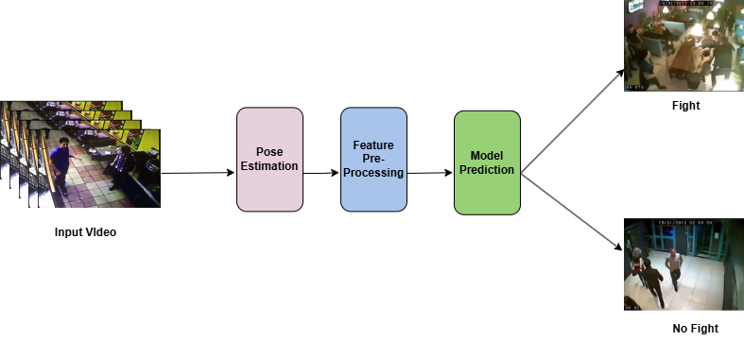
Fig1:Work Flow of the Prediction System
A. Data Collection
The project data was structured into video clips that categorized all the activities as fights or not fights. Preprocessing was done to all videos and pose key points extracted to get the 132 features per frame based on all body joints' x and y coordinates. In the case of video shorter than 30 frames, zero padding was used, while longer videos were subjected to uniform sampling so that each video was brought to the same frame size. Each sample was thus a (30, 132) shaped array. The dataset was balanced in classes to avoid bias. The dataset was randomly split into training and testing in an 80:20 ratio while using stratified sampling to maintain the class distribution..
B. Data Preprocessing:
In this project, each video was first subjected to an extraction of 132 pose features from every frame related to the x-and y-coordinates for 66 key body joints detected by a pose estimation technique. All the videos were standardized to exactly 30 frames, as per the data requirements for each of the samples in the study. So, videos that had less than 30 frames were padded with zeros during processing until it reached 30 frames, while videos that had more than 30 frames were uniformly downsampled to eliminate the rest while still retaining only 30 frames as representative samples. Each sample ended up having a shape of (30, 132). Prior to feeding to the models, pose data was normalized to enhance model convergence. The entire dataset of 300 samples was split into 80% training and 20% testing under the original class distribution of stratified sampling for training and evaluation purposes. Further, the data also matched the inputs required for the LSTM and Bi-LSTM models, with its final shape ending up being (samples, timesteps, features) = (300, 30, 132).
C. Feature Selection:
The selection of the features in this project is done predominantly through pose estimation output structure. For each frame extracted from videos, a pose keypoint representing human skeletal joints is produced, and for every frame, 132 numerical features are generated in the (x, y) coordinates and detection confidence scores for key joints. These were chosen because they really captured the spatial arrangement and dynamics of people's movements, which is one of the most obvious pointers in identifying violent versus non-violent actions. We did not even use PCA or manual selection on the features for reduction, as we simply worked with the raw pose key point data so that we did not lose any important motion information. The pose features were consistent across frames and videos so that they entered into the models—that is, Random Forest, LSTM, and Bi-LSTM—with a relatively standardized input format to learn distinguishable patterns without having to go into much preprocessing or feature engineering.
D. Models Architecture :
In this project, three different models were implemented and evaluated: Random Forest, Long Short-Term Memory (LSTM), and Bidirectional Long Short-Term Memory (Bi-LSTM). Each model utilized the extracted pose features to classify fight and non-fight scenarios.
1.Random Forest Classifier:
Implementation of the Random Forest classifier was the first model to be put in place. It is a traditional algorithm based on ensemble learning. This means that during training, which happens rather quickly, it constructs several decision trees and outputs the mode of their predictions. In this project, the Random Forest model trained using 100 estimators, where the input was the flattened feature vectors of all frames. Despite being rather simple and having generalization ability, the Random Forest achieved a moderate accuracy of 63% on the test set. Although it does well with high-dimensional feature spaces, it fails to capture the temporal dynamics that exist within the video sequences causing the performance to drop down.
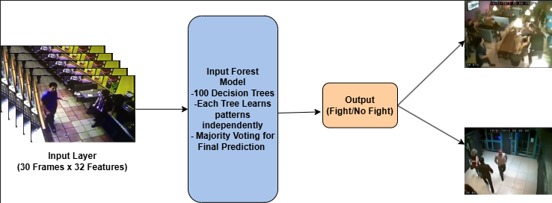
Fig2: Architecture Diagram of Random Forest classifier
2.LSTM(Long Short- Term Memory) Model:
Long Short-Term Memory (LSTM) networks are specialized forms of a recurrent neural network that learn long-term dependencies in the sequential data. The overall architecture of the LSTM model consisted of just one LSTM layer of 64 units, a dropout layer of 0.5 for preventing overfitting, then followed by a dense layer having 32 neurons with ReLU activation. The model was ended with an output layer that used sigmoid activation for binary classification. The LSTM model was trained for 30 epochs using the Adam optimizer and a binary cross-entropy loss function. Unlike Random Forest, the LSTM architecture captured temporal relationship across frames; thus, allowing much improvement in performance, which achieved 75% accuracy of test data.
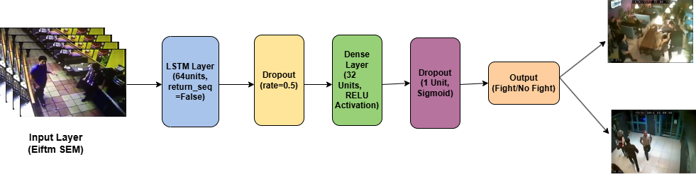
Fig3: Architecture Diagram of LSTM Model
3. Bi-Directional LSTM Model:
The third model proposed was the Bidirectional LSTM (Bi-LSTM), which is an improved version of LSTM that accepts input sequences along the forward and backward directions. This design helps the network to capture the patterns from the past and the next contexts together, thus enhancing sequence dynamics understanding. The Bi-LSTM architecture consisted of a bidirectional LSTM layer of size 64 (returning sequences); afterward, there was a dropout layer, one more bi-LSTM layer of size 32, and finally a dense output layer with a sigmoid activation. The same set of training parameters was implemented as with standard LSTM. Although Bi-LSTM theoretically had some advantages over standard LSTM, it ended having less test accuracy at 65%, possibly due to limited dataset size or overfitting issues.
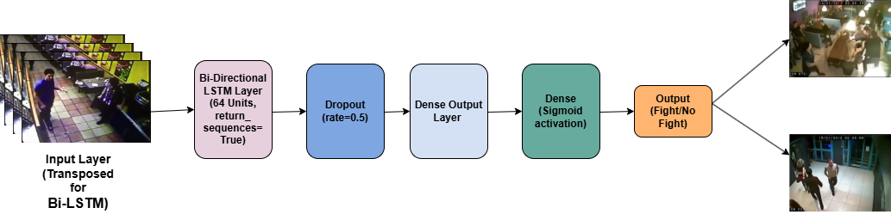
Fig4: Architecture Diagram of Bi- LSTM Model

Implementation Details:
- Compile the Model:
For this project, each model was compiled using appropriate loss functions and optimizers based on the problem type, that is, binary classification (fight vs. non-fight detection). The Random Forest Classifier does not require compilation as it is a tree-based ensemble method in scikit-learn, whereas for the deep learning models—LSTM and Bi-LSTM—the compilation is paramount. The LSTM and Bi-LSTM models share the common key feature of the Adam optimizer: the learning rate is adapted throughout the course of training, thus leading to generally faster convergence. The binary cross-entropy loss function was chosen due to its binary output: 0 or 1. The performance metric taken for evaluation during training was accuracy, measuring how many of our predictions were correct. With such a compilation setup, we ensured that the optimization and learning processes corresponded intrinsic with the nature of our classification task.
- Train the Model:
Three distinct models have been designed using the processed pose feature data, including the Random Forest, LSTM, and BILSTM. The Random Forest classifier is trained by using 100 decision trees (n_estimators=100) and uses a random state fixed for reproducibility. LSTM has 64 LSTM cells with a dense layer of 32 neurons with dropout layers for overfitting, where the training takes place for 30 epochs for a batch size of 16 using Adam optimizer while using binary cross-entropy loss. It is similar for the Bi-LSTM model, which consists of a bidirectional LSTM of 64 units followed by another bidirectional LSTM of 32 units and dropout for regularization and trained with 30 epochs and 32 in each batch. All the deep learning models used 80 percent of the data to train and validated the remaining 20 percent. After training, the Random Forest model gave an accuracy of 63%, whereas the LSTM model performed much better with an accuracy of 75%, and the Bi-LSTM model scored at an accuracy of 65%. All models are assessed in terms of accuracy, confusion matrix, and the classification report metrics in recognizing fight versus non-fight scenarios using pose sequences.
- Implementing the models:
The project is developed in Python using rich support from libraries including TensorFlow, Keras , NumPy, scikit-learn, Matplotlib, and Seaborn. The pose key points extracted from the video frames would result in an input of 132 features per frame (66 key points x 2 coordinates), and therefore, each video was standardized to 30 frames resulting into a well-defined input shape of (30, 132). The Random Forest Classifier is developed by using scikit-learn, while the LSTM and Bi-directional LSTM (Bi-LSTM) models are built using Keras. The 64-unit LSTM layer of the LSTM model is followed by two dense layers, while the Bi-LSTMs consist of two Bidirectional LSTM layers (64 and 32 units) with dropout regularization. All the models use the Adam optimizer and binary cross-entropy loss for their compilation, along with training for 30 epochs with an adequate batch size (Batch size-16 for LSTM, Batch size-32 for Bi-LSTM). The experiments were conducted on a CPU-based system indicating efficiency in training these models without requiring high-end computation resources.

Results and Discussion:
Testing on the Random Forest Classifier returned a classification accuracy of 63% on the test data. This accuracy indicates a reasonable performance for a classical machine-learning method; however, the performance was limited due to the sequential nature of the pose features, which are not the inherent nature of Random Forests to capture. However, it has provided a very good baseline and showed that pose features alone can provide some reasonable discrimination between fight versus non-fight activities.
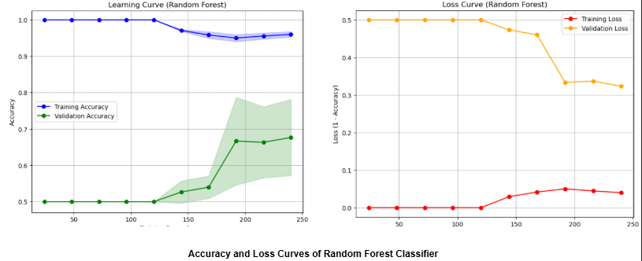
Fig5: Accuracy and Loss Curves of Random Forest Classifier
The LSTM model increased the accuracy significantly to 75%. This was enabled by using sequential information across the 30 frames for each video to allow the model to learn the temporal dependencies, thus giving improved performance on the classification task. The dropout layers also helped improve generalization by reducing overfitting, consequently giving far .
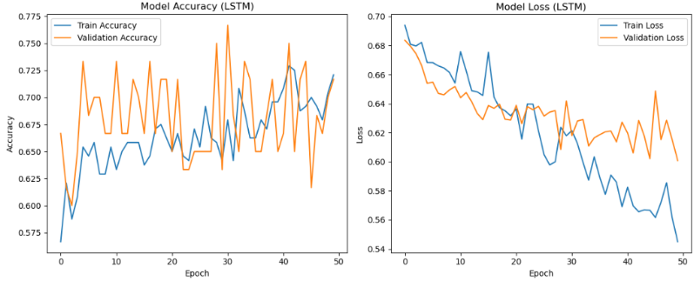
Fig6: : Accuracy and Loss Curves of LSTM Model
\more stable validation results than the Random Forest model. The Bi-LSTM model operates in both forward and backward directions in sequence processing and yielded an accuracy of 65%. Although Better than Random Forest, it failed to outperform the simple LSTM in this instance. Overfitting from small dataset size likely led to this since the increased complexity of Bi-LSTM did not yield improved generalization. Overall, the LSTM model proved to be the best in performance, demonstrating that the temporal modeling of pose features is very responsive to fight detection tasks through video.
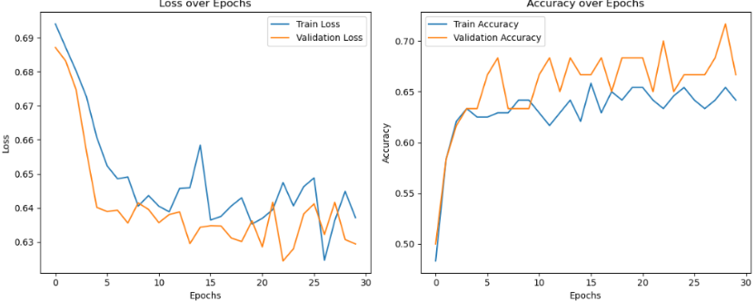
Fig7: Accuracy and Loss Curves of Bi-LSTM Model
Table 1: TRAINING AND VALIDATION ACCURACY OF MODELS
S.no | Model Name | Training Accuracy | Validation Accuracy
1. | Random Forest Classifier | 0.95(95%) | 0.63(63%)
2. | LSTM Model | 0.7016(70.16%) | 0.75(75%)
3. | Bi-LSTM Model | 0.6179(61.79%) | 0.65(65%)
Table2: TRAINING AND VALIDATION LOSS OF MODELS
S.NO | Model Name | Training Loss | Validation Loss
1. | Random Forest Classifier | 0.5(5%) | 0.37(37%)
2. | LSTM Model | 0.2984(29.84%) | 0.25(25%)
3. | Bi-LSTM Model | 0.3821(38.21%) | 0.35(35%)

Project Outcomes:
Through the rigorous experimentation of three different models, i.e., Random Forest, LSTM and Bi-LSTM, this project achieved its main outcome, the success in making a detection scheme automated in which it automates fight detection in videos through pose-based feature extractions. The maximum percentage accuracy of classification was achieved by the LSTM model, completing the temporal dynamics that exist in human movements, while the other classifications recorded were 63% and 65% accuracies achieved by Random Forest and Bi-LSTM, respectively. Random Forest stood well with respect of the pose feature, needing no consideration for temporal modelling, and Bi-LSTM was able to portray the significance of bidirectional temporal information. This part also leads to a lightweight and efficient implementation, manageability of trainable parameters, minimal resource usage, and suitability of itself for real or near-real time applications. The entire project maybe summarized to indicate that pose based features can actually be combined with machine learning and deep learning techniques relevant for violence detection with surveillance and security systems.
Limitations and Challenges:
Indeed, promising results were obtained from the project, but it was still faced with a number of limitations and some hurdles. The major limiting factor become the thing reliance of pose estimation quality and consistency, that imprecise or absence key points because occlusion or motion blur or just poor lights directly affect the performance quality of the model. Also, the data set size is also limited since it had only 300 video samples (150 fights and 150 non-fights). This limited the generalization ability of the deep learning models making them subject to slight overfitting. While Random Forest does a good job of being given static pose features, it falls short when compared to LSTM-based models in terms of being able to deal with temporal dynamics well. For instance, LSTM and Bi-LSTM models: Although they capture the element of temporal relationship, they require longer training times and are quite sensitive to hyperparameter tuning. Another problem issues were as in the uniformity of length frames-lacks in this format, i.e., 30 frames per one video-that might result in either duplication of frames or dropout of some frames, losing important motion information.Most importantly, their characteristics about real-life fight scenes are complicated as they are full of interactions, a lot of people, and chaotic movements against which the current model built in isolation pose key points might fail to judge action without the input of scene understanding or semantics of action.
Conclusion:
This project was successful in the exploration of fight detection in videos using the pose-based features and also evaluation of three models like Random Forest, LSTM, and Bi-LSTM. Out of these approaches, LSTM showed the highest performance with 75% accurate prediction as it could well capture the sequential aspect of human movement movements shown in the videos. The Random Forest-based classifier, on the other hand, would easily produce a good baseline of 63% accuracy and Bi-LSTM showed moderate performance at 65%. Results have thus shown that temporal cases in deep learning have proved generally better than LSTM networks but always more excellent than other machine learning methods. But there were challenges, with limited dataset size, potential loss of important details of fine-grained movements, and computational cost, which within it suggest possible improvements for future work. In short, this research mainly focused on the 'importance of temporal modelling in pose-based actions video recognition.
References
[1] Yan S., Xiong Y., Lin D. (2018). Spatial Temporal Graph Convolutional Networks for Skeleton-Based Action Recognition. Proceedings of the AAAI Conference on Artificial Intelligence.
[2]Breiman L. (2001). Random Forests. Machine Learning, 45(1), 5–32.
[3]Donahue J., Anne Hendricks L., Guadarrama S., Rohrbach M., Venugopalan S., Saenko K., Darrell T. (2015). Long-Term Recurrent Convolutional Networks for Visual Recognition and Description. Proceedings of the IEEE Conference on Computer Vision and Pattern Recognition (CVPR).
[4]Shahroudy A., Liu J., Ng T.T., Wang G. (2016). NTU RGB+D: A Large Scale Dataset for 3D Human Activity Analysis. Proceedings of the IEEE Conference on Computer Vision and Pattern Recognition (CVPR).
[5]Simonyan K., Zisserman A. (2014). Two-Stream Convolutional Networks for Action Recognition in Videos. Advances in Neural Information Processing Systems (NeurIPS).
[6] Klaser A., Marszałek M., Schmid C. (2008). A Spatio-Temporal Descriptor Based on 3D-Gradients. British Machine Vision Conference (BMVC).
[7]Hochreiter S., Schmidhuber J. (1997). Long Short-Term Memory. Neural Computation, 9(8), 1735–1780.
[8] Rahmani H., Mian A. (2016). 3D Action Recognition from Novel Viewpoints. Proceedings of the IEEE Conference on Computer Vision and Pattern Recognition (CVPR).
[9] Zhang Z., Cui P., Xu W. (2019). Violence Detection in Video by Using a Motion Vector CNN. Journal of Visual Communication and Image Representation, 59, 185–195.
[10] Liu J., Luo J., Shah M. (2009). Recognizing Realistic Actions from Videos in the Wild. Proceedings of the IEEE Conference on Computer Vision and Pattern Recognition (CVPR).
[11]L. Wang, Y. Xiong, Z. Wang, and Y. Qiao, "Temporal segment networks: Towards good practices for deep action recognition," European Conference on Computer Vision (ECCV), pp. 20–36, 2016.
[12]H. Kuehne, H. Jhuang, E. Garrote, T. Poggio, and T. Serre, "HMDB: A large video database for human motion recognition," Proceedings of the IEEE International Conference on Computer Vision (ICCV), pp. 2556–2563, 2011.
[13]B. Fernando, E. Gavves, M. Jos Oramas, A. Ghodrati, and T. Tuytelaars, "Modeling video evolution for action recognition," Proceedings of the IEEE Conference on Computer Vision and Pattern Recognition (CVPR), pp. 5378–5387, 2015.
[14]J. Donahue, L. Anne Hendricks, S. Guadarrama, M. Rohrbach, S. Venugopalan, K. Saenko, and T. Darrell, "Long-term recurrent convolutional networks for visual recognition and description," Proceedings of the IEEE Conference on Computer Vision and Pattern Recognition (CVPR), pp. 2625–2634, 2015.
[15]R. Girdhar, D. Ramanan, A. Gupta, J. Sivic, and B. Russell, "ActionVLAD: Learning spatio-temporal aggregation for action classification," Proceedings of the IEEE Conference on Computer Vision and Pattern Recognition (CVPR), pp. 971–980, 2017.
[16]C. Feichtenhofer, A. Pinz, and A. Zisserman, "Convolutional two-stream network fusion for video action recognition," Proceedings of the IEEE Conference on Computer Vision and Pattern Recognition (CVPR), pp. 1933–1941, 2016.
[17]D. Tran, L. Bourdev, R. Fergus, L. Torresani, and M. Paluri, "Learning spatiotemporal features with 3D convolutional networks," Proceedings of the IEEE International Conference on Computer Vision (ICCV), pp. 4489–4497, 2015.
[18]J. Yue-Hei Ng, M. Hausknecht, S. Vijayanarasimhan, O. Vinyals, R. Monga, and G. Toderici, "Beyond short snippets: Deep networks for video classification," Proceedings of the IEEE Conference on Computer Vision and Pattern Recognition (CVPR), pp. 4694–4702, 2015.
[19]H. Rahmani and M. Morteza, "Learning a deep model for human action recognition from novel viewpoints," IEEE Transactions on Pattern Analysis and Machine Intelligence, vol. 40, no. 3, pp. 667–681, 2018.
[20]C. Schüldt, I. Laptev, and B. Caputo, "Recognizing human actions: A local SVM approach," Proceedings of the International Conference on Pattern Recognition (ICPR), vol. 3, pp. 32–36, 2004.

